FW: An R package for Finlay-Wilkinson Regression that Incorporates Genomic/Pedigree information and Between-Environment Covariance

Lian Lian1* and Gustavo de los Campos1,2

1. Department of Epidemiology & Biostatistics, Michigan State University, 909 Fee Road, Room B601, East Lansing, MI, 48824.

2. Department of Probability and Statistics, Michigan State University.  
*Corresponding author (lianl0501@gmail.com )

# Abstract

The Finlay-Wilkinson Regression is a popular method among plant breeders to describe genotype by environment interaction. The standard implementation is a two-step procedure that uses environment (sample) means as covariates in a within-line ordinary least squares (OLS) regression. This procedure can be suboptimal for at least four reasons: (i) in the first step environmental means are typically computed without considering variety intercepts and slopes, (ii) in the second step uncertainty about the environmental means is ignored, (iii) estimation is performed regarding lines and environment as fixed effects and (iv) the procedure does not incorporate genetic (either pedigree-derived or marker derived) relationships. Su et al. proposed to address these problems using a Bayesian method that allows simultaneous estimation of environmental and genotype parameters, and allows incorporation of pedigree information. In this article we: (i) extend the model presented by Su et al. to allow integration of genomic (e.g., SNP) and spatial information (covariance for environments), (ii) present an R package (FW) that implements these methods, and (iii) illustrate the use of the package using examples based on real data. The FW R-package implements both the standard two-step OLS method and a full Bayesian approach for Finlay-Wilkinson regression with a very simple interface. Using a real wheat data set we demonstrate that the prediction accuracy of the Bayesian approach is consistently higher than the one achieved by the two-steps OLS method.

# Introduction

Plant breeders use the Finlay-Wilkinson Regression (FW, Finlay and Wilkinson, 1963) to assess stability of varieties across different environments. The FW aims at assessing how the expected performance of a genotype varies as a function of the environmental mean. Usually this is achieved by regressing the mean performance of each genotype on each environment on the environmental mean. Compared with a completely un-structured genotype by environment interaction (G×E) model that fits every level of genotype and environment combination, the Finlay-Wilkinson regression is able to reveal a trend of variety performance across environments. Breeders can use this model to select for plants either based on stability or on responsiveness to environment potential (Walsh and Lynch, 2014).

The standard implementation of Finlay-Wilkinson regression is a two-step procedure whereas in the first step environmental sample means are computed and in the second step intercepts and slopes of each line are estimated by regressing, within line, the performance of each line on the estimated environmental means. This procedure has at least four potential limitations: (i) in the first step environmental means are typically computed without considering variety intercepts and slopes, (ii) in the second step, uncertainty about the environmental means is ignored (iii) the environmental means and the variety intercepts and slopes are regarded as fixed effects (this can lead to large sampling variance of estimates), and (iv) the procedure does not offer a clear way of incorporating pedigree or molecular marker information when estimating the intercepts and slopes of the lines. These drawbacks can induce biases (especially in incomplete designs where a few lines are evaluated in each environments) and lead to large sampling variance of estimates.

Su et al. (2006) proposed a Bayesian method that addresses the limitations of the standard two-step procedure. The methodology described by Su et al.: (1) uses a Gibbs sampler that allows estimating environmental and genotype parameters jointly, (2) fully accounts for confounding and uncertainty about environmental means, (3) treats environmental means and the intercepts and slopes of the lines as random—this treatment usually perform better than ordinary least squares in terms of mean-squared error and of prediction accuracy, especially when the number of parameters to be estimated is large relative to sample size (Copas, 1983; Frank and Friedman, 1993), and (iv) allows incorporating pedigree information into the model. Using simulations, Su et al. (2006) reported better statistical performance of the Bayesian method for estimating model parameters. In this article we extend the model proposed by Su et al. (2006) in ways that allow incorporating genomic (e.g., SNP) information and environment covariance.

To the best of our knowledge the methodology described by Su et al. for animal breeding applications has not been considered in plant breeding, and there is no publicly available user-friendly software for implementing a Bayesian FW regression. Therefore, in this article we introduce an R-package (R Development Core Team, 2011) that implements the Finlay Wilkinson regression. The FW package implements both the two-steps ordinary least squares (OLS) procedure and Bayesian single step procedure that allows incorporating covariance structure for varieties (e.g., a pedigree or marker-derived kinship matrix) and environments. We describe the methods implemented in the package and show with examples how this package can be used to perform the Finlay-Wilkinson regression with both methods. Finally, we present an evaluation of prediction accuracy for the Bayesian and two-step OLS methods with a wheat data set.

# Model Specification and Algorithm

In a reaction norm model (Gregorius and Namkoong, 1986; Perkins and Jinks, 1968) the phenotypic record of the th replicate of the th variety observed in the th environment is modeled as follows

[Eq. 1]

where is the main effect of th variety and is the main effect of the th environment, and is an error term, usually assumed to be IID normal with mean zero and variance . When we reorganize Eq. 1 into the form: , we can recognize that is the change of expected variety performance per unit change of the environmental mean (). If there are no replicates the index *k* can be removed. With this, the equation reduces to . The collection of parameters to be estimated from the model of Eq. 1 include the intercept and the vectors of effects: , and .

## Estimation using two steps methods

In this section we describe how the two-step procedure as implemented in the FW package.

**Step 1**, estimates the environmental means (or more precisely the deviations of the environmental means from the overall mean, ) using a main-effects least-squares regression of the form

[Eq. 2]

The above regression yields estimates of deviations of the environmental means from the overall means (); these are used as covariates in the second step.

**Step 2**, estimate the intercept () and regression coefficient () of each line using the following least-squares regression

[Eq. 3]

The above regression yields estimates of the desired parameters (, , ).

The standard Finlay-Wilkinson regression (Finlay and Wilkinson, 1963) is a special case of the general two-step method: the environmental means are computed without considering genotype effects (this amounts to drop the effects of genotypes in Eq. 2) and then, fitting Eq. 3 separately within each line in the second step. Both steps in the standard Finlay-Wilkinson regression were implemented with OLS methods. The FW package implemented the standard Finlay-Wilkinson regression in a slightly different manner: (1) The in Eq. 2 was obtained as , where is the mean performance of all varieties on environment j and is the overall mean of all observations. (2) Equation 3 was fitted as by a single OLS step where is the incidence matrix that relates to and . We used a single linear regression in step 2 for the purpose of obtaining a single estimate of residual variance and the parameter estimates for **g** and **b** will not be affected.

## Bayesian approach

Bayesian inferences are based on the posterior distribution of unknown parameters given the data: , where represents the collection of the unknowns: , , , ,,, , , is the conditional distribution of the data given the parameters and is the joint prior distribution assigned to the model uknowns. According to Eq. 1 and assuming IID normal residuals, we have

.

In the FW package, the prior density is assumed to have the following form: . The residual variance is assigned a scaled-inverse distribution: , with degrees of freedom (>0) and scale parameter (>0), in the parameterization used . The overall mean is assigned a flat prior. The prior distributions for , , , are all multivariate Normal: ,, , where **H** is a covariance structure describing co-variances between the environmental means (this can be a covariance structure based on spatial information) and , **A** is a covariance structure describing co-variances between levels of the random effects **g** and **b** (**A** could be either a pedigree or marker-derived relationship matrix). Independence between the effects of the levels of any of the random effects can be obtained by setting either **A** or **H** to be an identity matrix. Since , and are also unknown, they are assigned scaled-inverse- distributions whose shape are controlled by variance-specific degree of freedom and scale hyper parameters. The FW package offers users the possibility of specifying hyper parameters (degree of freedom and scale parameters); however, if these are not specified, specific sets of rules similar to those described in (Pérez et al., 2010) are used to determine those parameters. Further details about this are given in the supplemental files.

In the model described above the posterior density does not have a closed form; however, estimates of features of the posterior distribution (e.g., posterior means, posterior standard deviations, or credibility regions) can be derived using Monte Carlo Methods. The FW package draws samples from the posterior distribution of the model using a Gibbs sampler (Casella and George, 1992; Geman and Geman, 1984) similar to the one described in (Su et al., 2006), details of the implementation of Gibbs sampler are provided in the supplemental files.

# Software

The FW package implements both a two-steps OLS procedure and the Bayesian model described in the previous section. Type the following command in R will install the package:

library(devtools)

install_github("lian0090/FW")

**Wheat data set**

The package includes a data set that can be used to run examples. The data set (originally made publicly available by Crossa et al., 2010) contains data for 599 wheat lines from CIMMYT’s Global Wheat Program and evaluated for grain yield in four environments. The dataset becomes available in the R environment by running the following R-code:

library(FW)

data(wheat)

Function library() loads the package, and data() loads datasets included in the package into the environment. The above code loads the following objects into the environment: (i) wheat.Y, a data.frame (2396 × 3) containing the grain yield (average of two plot records, $y) of 599 wheat lines ( $VAR) in four environments ($ENV), (ii) wheat.G (599 × 599) is a genomic relationship matrix computed from DArT markers. Further details about this data set can be found in Crossa et al. (2010).

## User Interface

All the arguments of the FW function have default values, except the response variable and the corresponding identifiers for varieties and environments. A basic call to the FW program is as follows.

|  |  |
| --- | --- |
| Box 1: Basic Call of the FW Function | |
| 1  2  3  4  5 | library(FW)  data(wheat)  attach(wheat.Y)  lm1=FW(y=y,VAR=VAR,ENV=ENV,method="OLS")  lm2=FW(y=y,VAR=VAR,ENV=ENV) |

When the call of the FW function is done using the code in line 4 of Box 1, FW fits a Finlay-Wilkinson regression with the two-steps OLS method: y (numeric, *n*, NAs are allowed) is the response variable, VAR (character, *n*, NAs are not allowed) are the identifiers for the varieties which are treated as labels; ENV (character, *n*, NAs are not allowed) are the identifiers for the environments; method is used to describe what method to use: "OLS" for ordinary least squares. The default method ("Gibbs") is the Bayesian regression; this can be invoked using the code in line 5 of Box 1. By default, a single chain of Gibbs sampler is run with a total of 5,000 cycles and the samples from the first 3,000 cycles are used for Burn-in, samples from the remaining 2,000 cycles for inference (the user is advised to run longer chains and to check convergence as well as the size of Monte Carlo errors). The FW function provides many additional arguments that can be used to specify the model (e.g., providing co-variance matrices for varieties and environments, user-defined values for hyper-parameters) and the algorithm (number of chains, numbers of iterations, etc.); details can be found in the user manual and in the examples presented below.

After fitting either OLS or Gibbs method, FW function returns a list with estimates and arguments used in the call, a brief description of the outputs follows.

## Return

Box 2 shows the structure of the object returned after calling the FW function (The structure was generated by line 1 of Box 2). The first element $y of the list is the response vector used in the call to FW, $whichNa gives the position of the entries in y that were missing, $mu (vector), $g (matrix), $b (matrix), $h (matrix) are the estimated posterior means of , **g**, **b**, **h**; $yhat (matrix) is the estimated posterior means of the predictor : ; $SD.mu (vector), $SD.g (matrix), $SD.b (matrix), $SD.h (matrix) and $SD.yhat are the estimated posterior standard deviation for , **g**, **b**, **h** and respectively.

With OLS method, $g, $b, $h and $yhat all have only one column; with Gibbs method each column provides estimates derived from one MCMC chain. Since the default behavior is to run only one chain the outputs in Box 2 contain only one column; however, if multiple chains are run, estimates from different chains are provided in different columns.

The output $var_e, $var_g, $var_b, $var_h are the estimated posterior means for , , and (only available for Gibbs method). Each element of $var_e, $var_g, $var_b and $var_h correspond to estimates derived from different chains; $SD.var_e, $SD.var_g, $SD.var_b and $SD.var_h are the estimated posterior standard deviation for , , and , respectively.

|  |  |
| --- | --- |
| Box 2: Structure of the object returned by FW | |
| 1  2  3  4  5  6  7  8  9  10  11  12  13  14  15  16  17  18  19  20  21  22  23  24 | str(lm2)  List of 24  $ y : num [1:2396] 6.17 3.14 2.74 3.26 4.99 ...  $ whichNa : int(0)  $ VAR : chr [1:2396] "775" "775" "775" "775" ...  $ ENV : chr [1:2396] "1" "2" "4" "5" ...  $ mu : Named num 4.64  $ SD.mu : Named num 0.0979  $ g : num [1:599, 1] -0.476 0.16 -0.611 ...  $ SD.g : num [1:599, 1] 0.224 0.219 0.224 0.208 ...  $ b : num [1:599, 1] 0.1604 -0.1255 0.251 ...  $ SD.b : num [1:599, 1] 0.237 0.236 0.235 0.24 ...  $ h : num [1:4, 1] 0.519 -0.186 -0.776 -1.383 ...  $ SD.h : num [1:4, 1] 0.096 0.0999 0.0999 0.103 ...  $ yhat : num [1:2396, 1] 5.17 4.3 3.56 2.81 5.21 ...  $ SD.yhat : num [1:2396, 1] 0.283 0.217 0.25 0.343 ...  $ var_e : Named num 0.3  $ SD.var_e : Named num 0.0111  $ var_g : Named num 0.0885  $ SD.var_g : Named num 0.0116  $ var_b : Named num 0.0973  $ SD.var_b : Named num 0.0132  $ var_h : Named num 0.926  $ SD.var_h : Named num 0.595 |

## Output files

No output files are generated for OLS method. For Gibbs method, samples for , , , , and (by default) the first two elements of **g, b, h** will be saved; as the Gibbs sampler collects samples, these samples are saved to the hard drive (only the most recent samples are retained in memory); by default, a thinning of 5 is used. Once the iteration process finishes, FW will read all the saved samples into a mcmc object, save the mcmc object into a file samps.rda, and remove the raw sample files. To prevent overloading the RAM with samples by default FW only save samples of the two first entries of the vectors of random effects; however the user can change this behavior by specifying which entries of the vectors are desired using the saveVAR (for **g** and **b**) and saveENV (for **h**) argument. These samples produced by FW can be used to assess convergence and to estimate Monte Carlo Standard Errors. The file samps.rda can be directly loaded into R using load('samps.rda' ). Once the object containing the samples is loaded in the R environment, the package coda (Plummer et al., 2006) can be used to obtain plots of the chains and compute convergence diagnostics.

# Application examples

In this section we illustrate via examples some of the features of the FW package; Example 1 illustrates how the package can be used to fit Finlay-Wilkinson regression by OLS method and Gibbs method with and without covariance structure and Example 2 describes how the package can be used for cross-validation analyses. Additional examples involving fine-tuning the Gibbs method (e.g., hyper-parameter setup, fitting more than two chains, specify saved samples) are provided as Supplementary data.

## Example 1: Fitting models with default setup for 599 wheat lines

Box 3 shows the code used to fit a FW regression using three different approaches: (i) a two-steps OLS model (code in line 3), (ii) a Bayesian FW regression assuming independence of lines and of environments (code in lines 5-6) and (iii) a Bayesian FW regression that incorporates genomic information (lines 8-9). In the Bayesian models, the seed for the random number generator can be specified using the argument seed (see lines 5-9) and the argument saveAt can be used to add a path and a pre-fix to be appended to 'samps.rda' file.

|  |  |
| --- | --- |
| Box 3: Fit models by default parameters | |
| 1  2  3  4  5  6  7  8  9  10  11  12  13  14  15  16  17 | library(FW); data(wheat); attach(wheat.Y)  OLS=FW(y=y,VAR=VAR,ENV=ENV, method="OLS")  GibbsI=FW( y=y,VAR=VAR,ENV=ENV, method="Gibbs",seed=12345,saveAt="GibbsI",nIter=50000,burnIn=5000)  GibbsA=FW(y=y,VAR=VAR,ENV=ENV, method="Gibbs",A=wheat.G,seed=12345, saveAt="GibbsA",nIter=50000,burnIn=5000)  load("GibbsIsamps.rda")  HPDinterval(samps[,c("var_e","var_g","var_b","var_h")])  load("GibbsAsamps.rda")  HPDinterval(samps[,c("var_e","var_g","var_b","var_h")]) |

Parameter estimates (estimated posterior means) can be directly extracted from the FW object as illustrated in Box 2. Other features of the posterior distribution (e.g., 95% credibility intervals for the parameters) can be obtained by post-hoc analyses of the samples included in the rda file generated by the program (see, line 13-17 of Box 3). In Table 1, we listed the estimates of variance components from the three models. For OLS method, only the residual variance is estimated. The estimated error variances are very similar across the three models. Also from Table 1, we can see that the estimated variance of the main effects of the environments is large relative to both the error variance and the phenotypic variance.

**Table 1.** Estimated variance components (posterior 95% credibility intervals in parenthesis) from different models

|  |  |  |  |  |
| --- | --- | --- | --- | --- |
| Parameters | FW output | OLS | GibbsI (A=I) | GibbsA (A=G) |
|  | $var_e | 0.32 | 0.30 (0.28, 0.32) | 0.30 (0.28, 0.32) |
|  | $var_g | NA | 0.09 (0.07, 0.11) | 0.11 (0.08, 0.14) |
|  | $var_b | NA | 0.10 (0.07, 0.12) | 0.13 (0.10, 0.17) |
|  | $var_h | NA | 0.90 (0.24, 1.90) | 0.88 (0.24, 1.88) |

The fitness of the models can be examined by the correlations between the observed values y and the fitted values  (line 1 of Box 4). The OLS model fitted the data better than both GibbsI and GibbsA: the correlation was 0.91 for the OLS method, 0.88 those for GibbsI and 0.86 for GibbsA.

|  |  |
| --- | --- |
| Box 4: Correlation between y and , and correlations for b among different models. | |
| 1  2 | cor(y,OLS$yhat);cor(y,GibbsI$yhat);cor(y,GibbsA$yhat);  cor(OLS$b,GibbsI$b);cor(OLS$b,GibbsA$b);cor(GibbsI$b,GibbsA$b) |

In Table 2, we listed the correlations among parameter estimates from different models (code for parameter b was provided in line 2 of Box 4), and noticed that correlations among parameters estimates from different models are high; this is expected considering that the data comes from a full factorial design where all lines are evaluated in all environments.

**Table 2**. Pearson’s product-moment correlation between parameter estimates derived by each of the three methods implemented in Box 3.

|  |  |  |  |
| --- | --- | --- | --- |
|  | OLS-GibbsI | OLS-GibbsA | GibbsI-GibbsA |
|  | 1.00 | 1.00 | 1.00 |
|  | 0.94 | 0.81 | 0.83 |
|  | 0.98 | 0.79 | 0.81 |
|  | 0.96 | 0.94 | 0.97 |

The pattern of variety performance in different environments can be visualized by plotting the observed and fitted values against the estimated environment effects. Figure 1 was generated by the calling of plot function in line 2-3 of Box 5. Each line in this plot correspond to a genotype. The comparison of the results from the OLS and GibbsA methods reveal interesting patterns: the OLS method predicts a much stronger extent of G×E (this is likely due to over-fitting, see Example 2 below) than the Bayesian method. The Bayesian method yields ‘smoother’ predictions, his is a direct consequence of the shrinkage-towards the mean induced in the Bayesian method by the use of correlations between genotypes (e.g., genomic relationships) and by treating effects as random.

To allow the user interpreting individual lines, the plot function can selectively plot user specified varieties through the argument plotVAR. Figure 2 has only five varieties and is produced by the code in line 5-10 of Box 5.

The slope in the plot corresponds to and the dashed grey line corresponds to a slope equals to 1 (), recall that represents the expected change in performance of the i*th* variety per unit change in the mean of the environment. We observe from Figure 4 that line ID=1081265 performs well in all environments and line ID=13302 is better adapted to good environments.

|  |  |
| --- | --- |
| Box 5: Plot fitted models | |
| 1  2  3  4  5  6  7  8  9  10 | par(mfrow=c(1,2))  plot(OLS,main="OLS", cex=0.2,lwd=0.2)  plot(GibbsA,main="GibbsA", cex=0.2,lwd=0.2)  plot(OLS, plotVAR=c("1081265","1101307",  "1295736", "13302" , "1343502"), main="OLS")  plot(GibbsA, plotVAR=c("1081265","1101307",  "1295736", "13302" , "1343502"), main="GibbsA") |

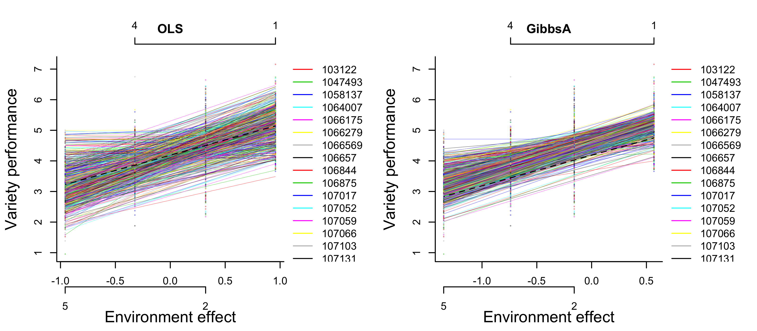

Figure 1. Plot of variety performance versus estimated environment values. Each line represents a different variety. Lines are fitted values and points are the cell means of genotype and environment combination. Labels in the horizontal bars are the environment labels, and can be removed by setting ENVlabel=F.

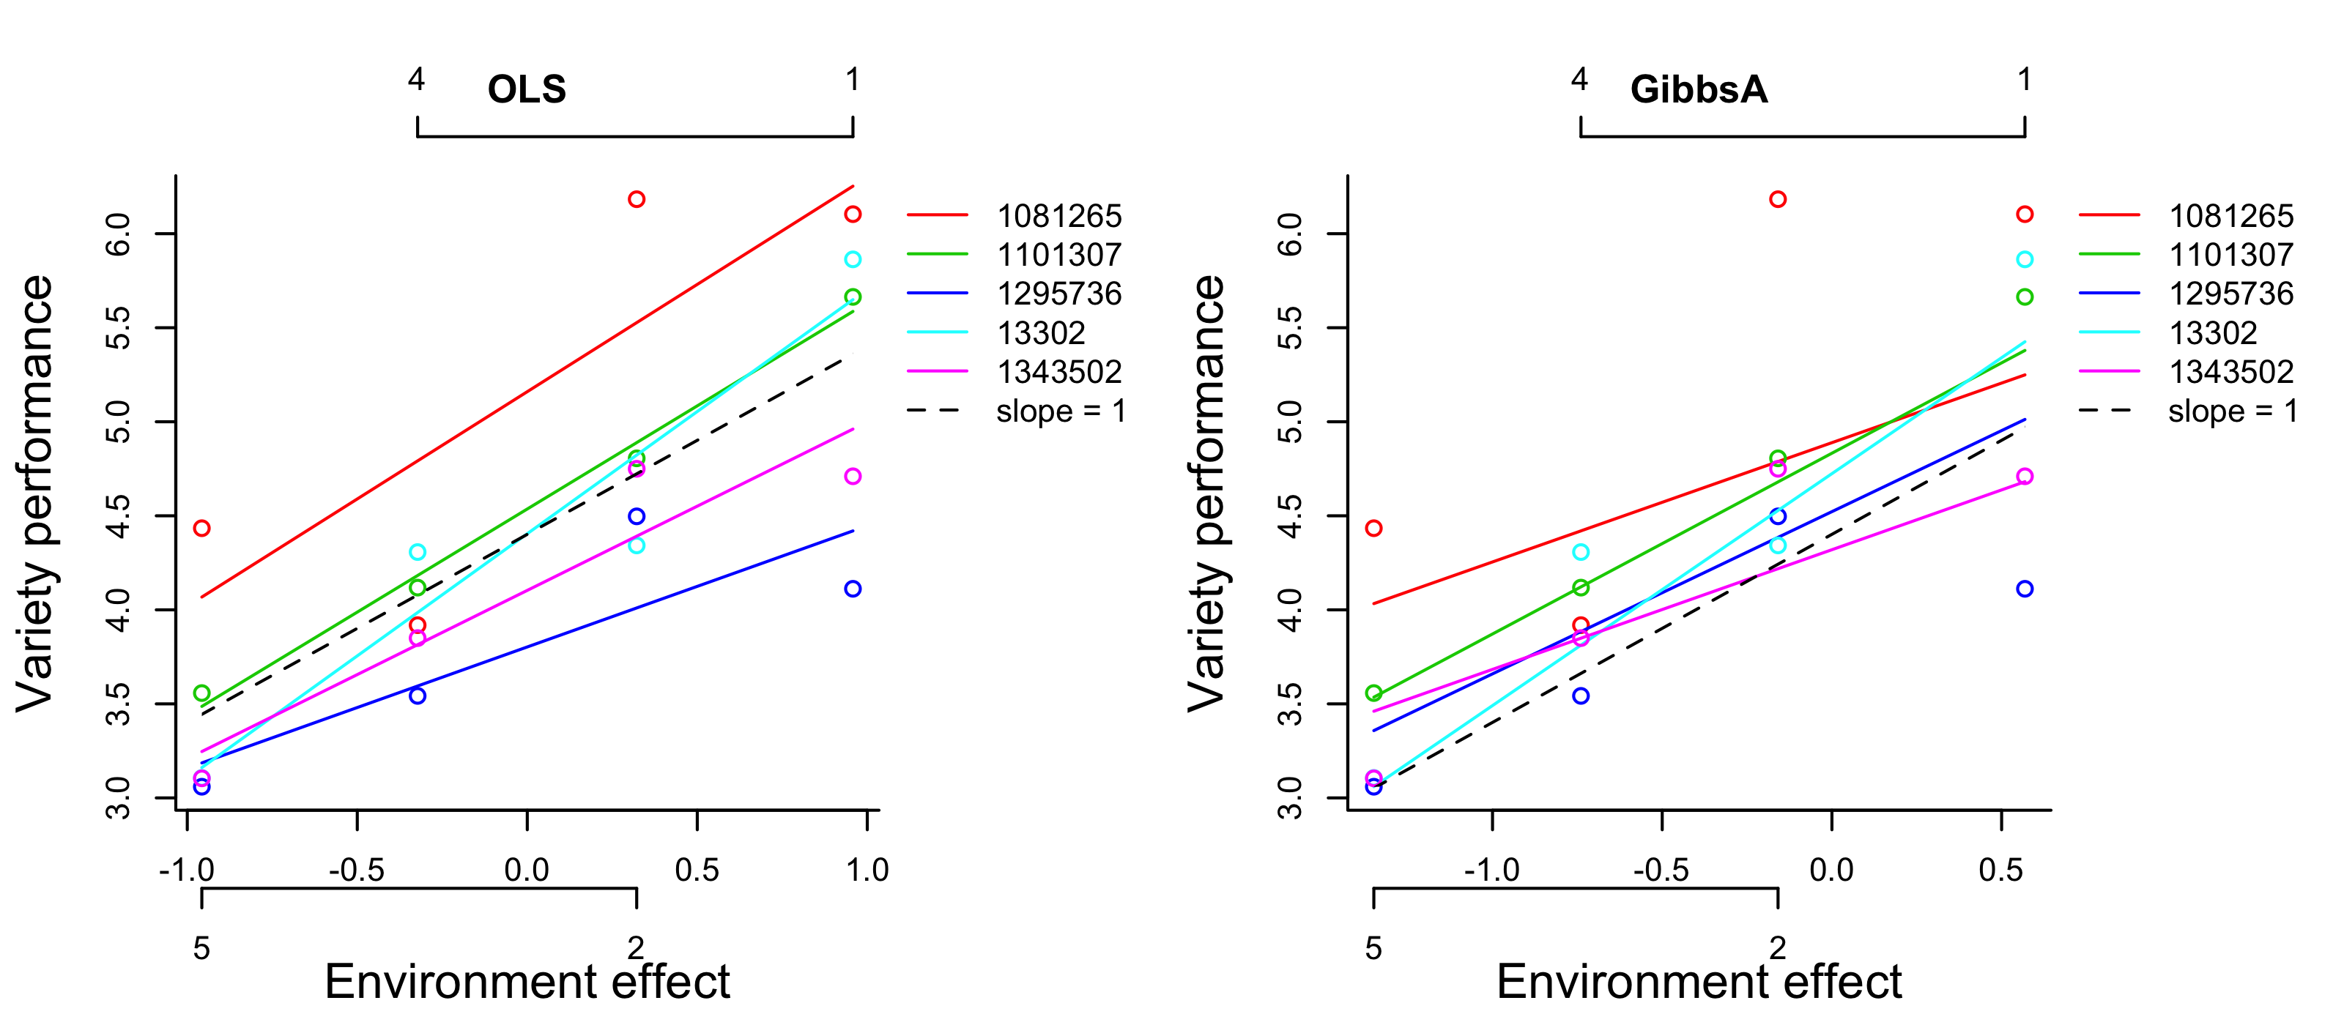

Figure 2. Plot of the performance of five varieties on estimated environment values. Each color represents a different variety. Lines are fitted values and circles are the cell means of genotype by environment combination. Labels in the horizontal bars are the environment labels, and can be removed by setting ENVlabel=F.

### Fitting models with environment covariance

Genomic relationship matrix is widely used in animal and plant breeding to predict the values of unobserved individuals. Similar borrowing of information can be done for environment effects. Environment covariance matrix can be constructed from measurement of environment covariates such as temperature, moisture, radiation etc. as demonstrated in (Jarquín et al., 2014). We do not have environment covariance matrix available for the wheat data set, but we are constructing two environment covariance matrixes to illustrate their uses in the FW package.

We constructed a covariance matrix H (line 1-3 of Box 6) that has high covariance between the first (has the highest environment effect, see Table 3) and the last environment (has the lowest environment effect, see Table 3). The covariance matrix was constructed this way in the hope that the two extreme environments can borrow information from each other and the new estimated environment effects will be somewhere in between the original estimates. We fitted GibbsH with this covariance matrix H by specifying H=H (line 4-5 of Box 6). The estimated environment effects from GibbsH are very close to the original estimated from GibbsI (Table 3). The correlation of between GibbsH and GibbsI are very high (0.9999975 obtained from running line 6 of Box 6). Since we have 599 replicates for each environment in the data set and borrowing information from other environments does not really change the estimation. Therefore, the using the covariance matrix H should be best when we have no or few observations for some environments.

We constructed another covariance matrix H2 from the cross product of  from GibbsI (line 8-9 of Box 6). To make this covariance matrix H2 full rank, we added a small value to the diagonal of H2 (line 10 of Box 6). We set all the observations in environment 4 as NA and used the FW model with covariance matrix H2 to estimate the effect of environment 4 (line 11-15 of Box 6). We can see in Table 3 that when H2 was included as the covariance matrix, even environment 4 is completely missing; the estimated environment effects were very close to the environment effects from the full data sets with GibbsI.

Table 3 Estimated environment effects from GibbsI and GibbsH

|  |  |  |  |
| --- | --- | --- | --- |
| ENV | GibbsI | GibbsH | GibbsH2 |
| 1 | 0.52 | 0.50 | 0.50 |
| 2 | -0.18 | -0.20 | -0.17 |
| 4 | -0.78 | -0.79 | -0.76 |
| 5 | -1.38 | -1.40 | -1.38 |

|  |  |
| --- | --- |
| Box 6: Including covariance matrix (H) for Environments in FW. | |
| 1  2  3  4  5  6  7  8  9  10  11  12  13  14  15 | H=diag(1,4)  H[1,4]=H[4,1]=0.8  colnames(H)=rownames(H)=c(1,2,4,5)  GibbsH=FW(y=y,VAR=VAR,ENV=ENV,  method="Gibbs",H=H,seed=12345,nIter=50000,burnIn=5000)  cor(GibbsI$yhat,GibbsH$yhat)  H2=tcrossprod(GibbsI$h)  H2=H2/mean(diag(H2))  diag(H2)=diag(H2)+0.01  whichNa=which(ENV==4)  yNA=y  y[whichNa]=NA  GibbsH2=FW(y=y,VAR=VAR,ENV=ENV,  method="Gibbs",H=H2,seed=12345,nIter=50000,burnIn=5000) |

### Assessment of convergence for Bayesian FW regressions

The convergence of Gibbs sampler can be examined by plotting the samples collected by FW. The code in Box 7 illustrates how to produce trace plots: lines 1-2 load and plot the samples from GibbsI and lines 3-4 do the same for GibbsA. Mixing was reasonably good (the samples jump from one end of the posterior to the other in relatively few iterations) in both cases for the variance components ( (var_e), (var_g), (var_b) ) , genotype main effects **g** (g), genotype slope **b** (b) and the function predictor (yhat). There are many high peaks in the trace plot of (var_h), which indicates that the distribution of is heavily skewed (which is also obvious from the density plot). This should be expected since there are only four levels of environment effect and scaled inverse chi-square distribution with few degrees of freedom is highly skewed. Figure 3 reproduces the trace plot of the variance components (var_e, var_g, var_b, var_h).

The mixing for the intercept and the environment effects (the entries of **h**) can be slow in multiplicative models (e.g., Shariati et al., 2009). Therefore, the user is advised to check both convergence to the posterior distribution and the magnitude of the MC standard errors. Convergence to the posterior distribution can be assessed using a trace plot or more formally using multiple chains. Figure 4 reproduces the trace plot for intercept and the first two elements of environment effect, h[1] and h[2], in all cases we used samples from model GibbsA. An example of how to assess convergence using multiple chains is provided in the supplemental materials. Finally, the magnitude of the MC standard errors can be determined suing the summary function of the coda package.

|  |  |
| --- | --- |
| Box 7: Plot Gibbs samples | |
| 1  2  3  4 | load("GibbsIsamps.rda")  plot(samps,ask=T)  load("GibbsAsamps.rda")  plot(samps,ask=T) |

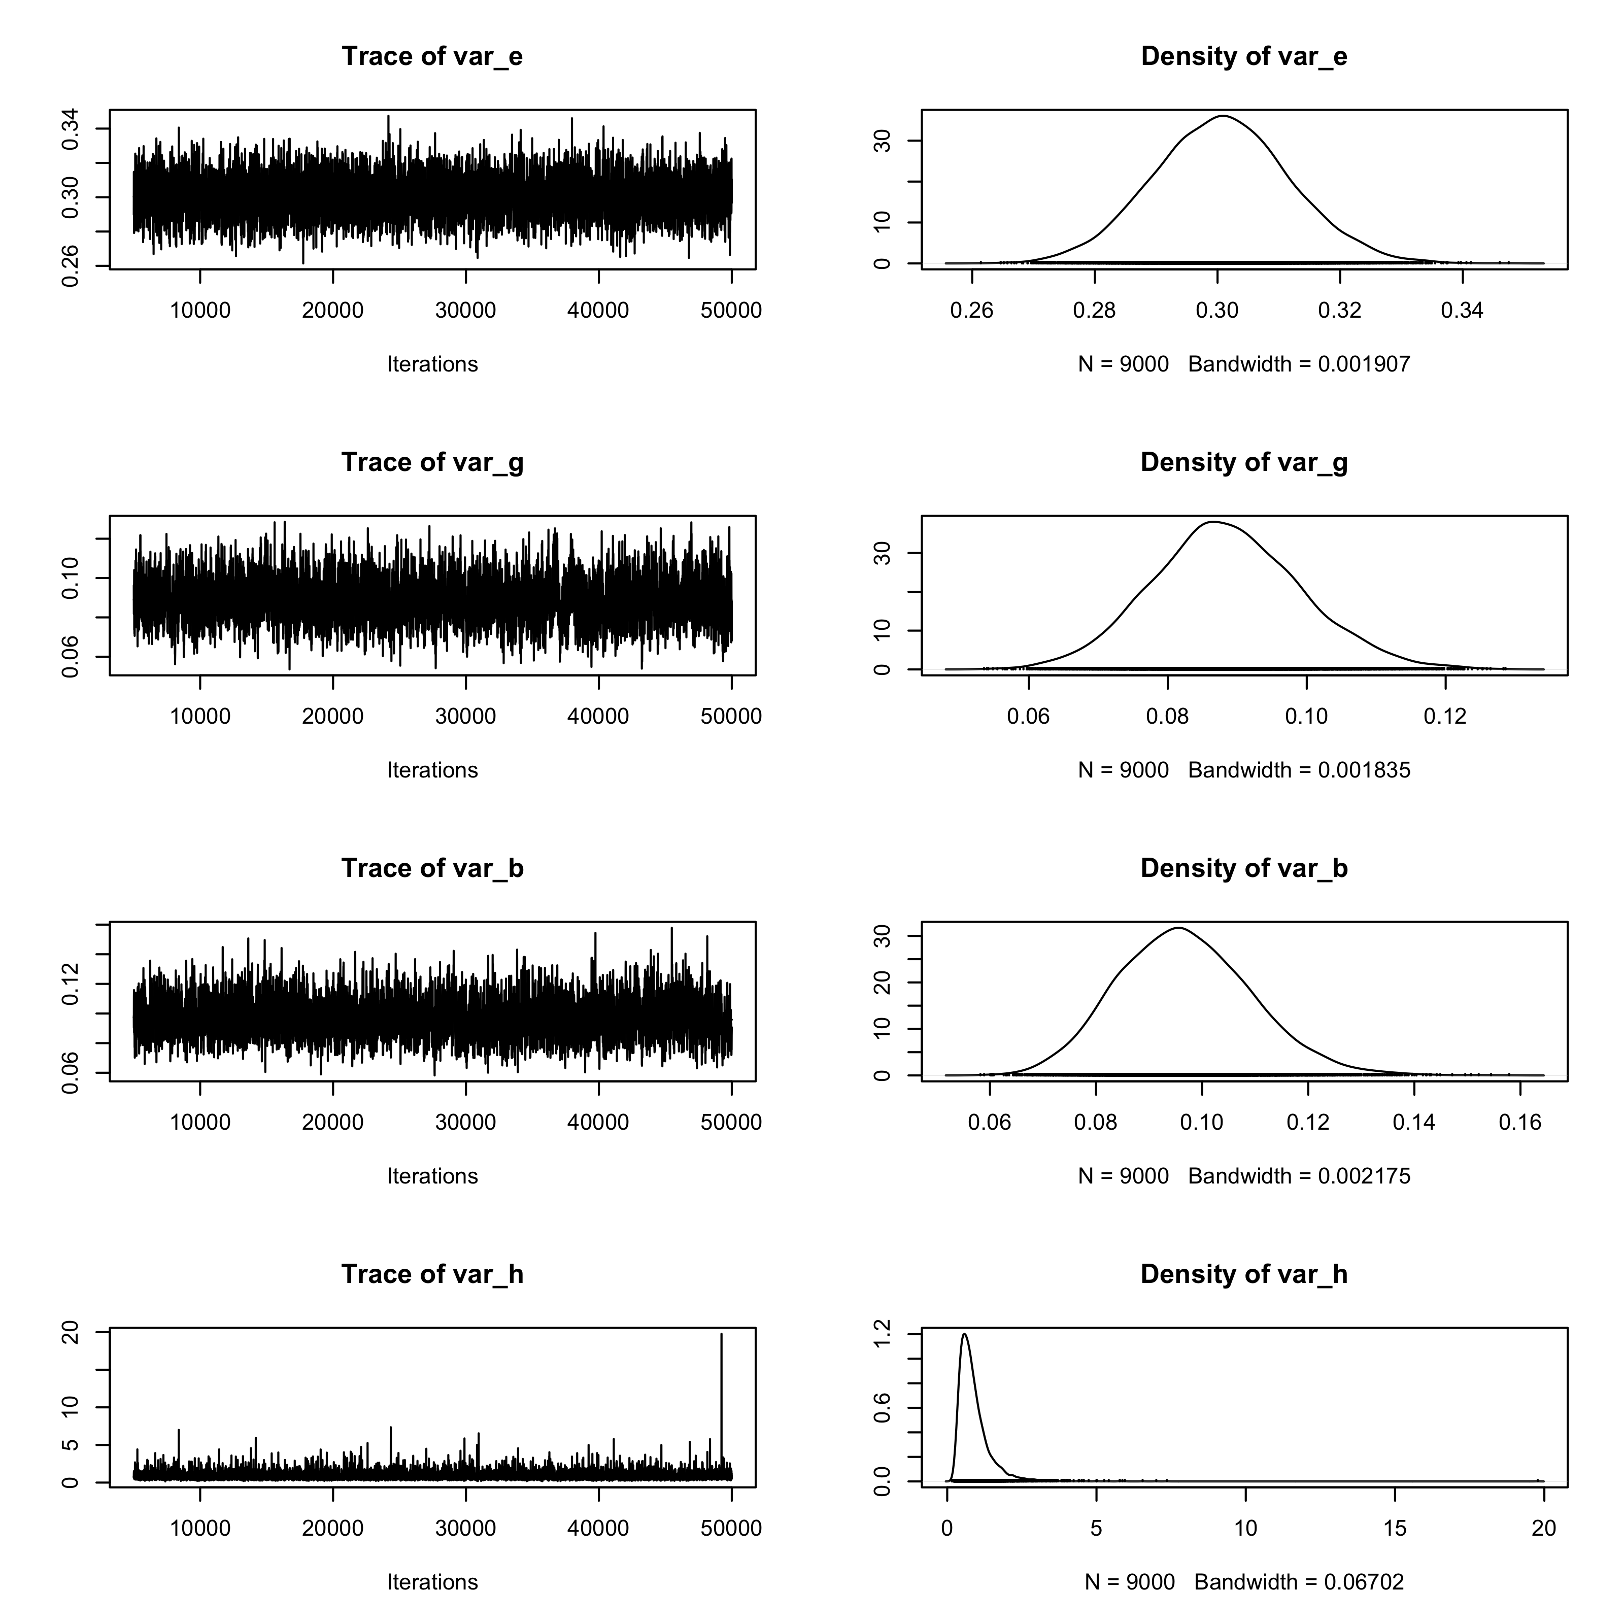

**Figure 3**. Trace and density plot of variance components from GibbsA.

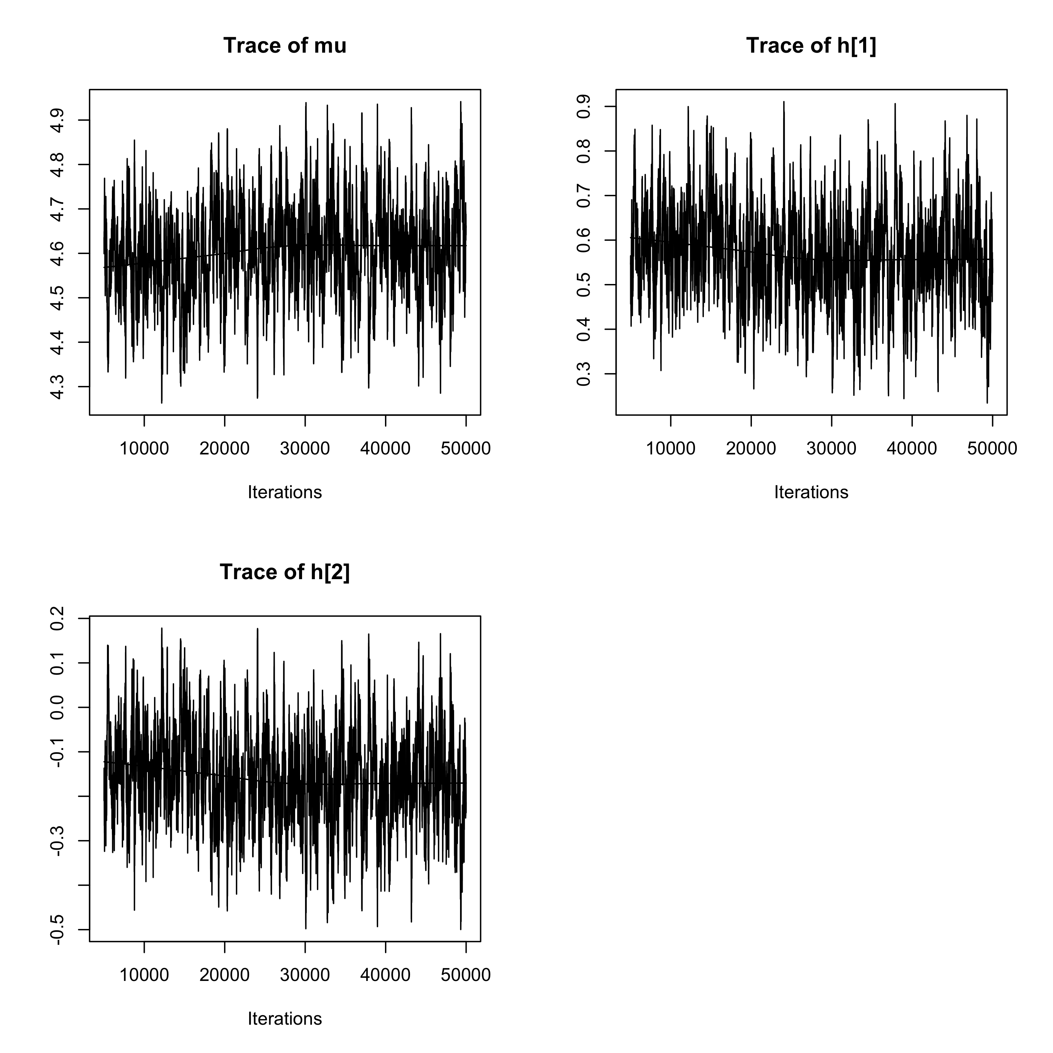

**Figure 4**. Trace plot of the intercept (mu) and the first two levels of environment effects (h[1])and h[2]) from GibbsA.

## Example 2: Assessment of prediction accuracy in testing data sets

Example 1 suggests that the OLS method fitted the training data better than the Bayesian models; this is expected because shrinkage reduces fitness to the data used to train a model. However, better model fitness does not necessarily imply higher prediction accuracy in validation data sets. In the following example we illustrate how to use the FW for assessment of prediction accuracy using cross-validation.

To assess the ability of different models for predicting new data, we modified the code in Box 3 by setting NA to randomly selected entries of the phenotypic vector (i.e., one record out of four per line was randomly selected and labeled as NA; see, code in lines 1-5 in Box 7). The FW package produces estimates and predictions for all the lines, environments and all the entries of the phenotypic vector, those that had observed values and those that had NA. Therefore, predictions for entries with masked phenotypes can be used to assess prediction accuracy in validation data sets (see lines 17-19 in Box 8). We repeated the code in Box 8 for 100 times and generated 100 random partitions of the data into training and testing sets. Each partition renders an estimate of prediction accuracy for each of the models.

|  |  |
| --- | --- |
| Box 8: correlation between y and for training and validation data sets. | |
| 1  2  3  4  5  6  7  8  9  10  11  12  13  14  15  16  17  18  19 | yNA=y  seed=12345; set.seed(seed)  #randomly masking one environment for each variety  whichNa=seq(from=0,to=2392,by=4)+sample(1:4,size=599,replace=T)  yNA[whichNa]=NA  OLS=FW(y=yNA,VAR=VAR,ENV=ENV, method="OLS")  GibbsI=FW(y=yNA,VAR=VAR,ENV=ENV,  method="Gibbs",seed=seed,nIter=50000, burnIn=5000)  GibbsA=FW(y=yNA,VAR=VAR,ENV=ENV,  method="Gibbs",A=wheat.G,seed=seed,nIter=50000,burnIn=5000)  cor(y[-whichNa],OLS$yhat[-whichNa,])  cor(y[-whichNa],GibbsI$yhat[-whichNa,])  cor(y[-whichNa],GibbsA$yhat[-whichNa,])  cor(y[whichNa],OLS$yhat[whichNa,])  cor(y[whichNa],GibbsI$yhat[whichNa,])  cor(y[whichNa],GibbsA$yhat[whichNa,]) |

The mean correlation (of the 100 replicates) between phenotypes and predictions in the training data set (i.e., for the entries of y that did not have missing values) follows the same patterns as in Example 1, where OLS fitted the data best: 0.95 for OLS, 0.89 for GibbsI and 0.86 for GibbsA. However, The mean prediction correlation (of the 100 replicates) for the entries of the validation set has reversed orders: 0.61 for OLS, 0.77 for GibbsI and 0.80 for GibbsA.

In Figure 5, we plotted the estimated prediction correlation between predictions and observations in training (1st row of plots) and testing (2nd row of plots) data sets. Plots in the 1st, 2nd, and 3rd column correspond to comparisons of: OLS vs. GibbsI, OLS vs. GibbsA and GibbsI vs. GibbsA, respectively. Within each plot each line represents the accuracy obtained in 100 partitions for one model. We observed that OLS always fitted the data better than GibbsI and GibbsA in the training data sets; however, GibbsI and GibbsA always outperformed OLS by a sizable margin in terms of prediction accuracy in testing data sets. Finally, incorporating genetic information (GibbsA) always led to higher prediction accuracy than models that assumed independence between lines (GibbsI).

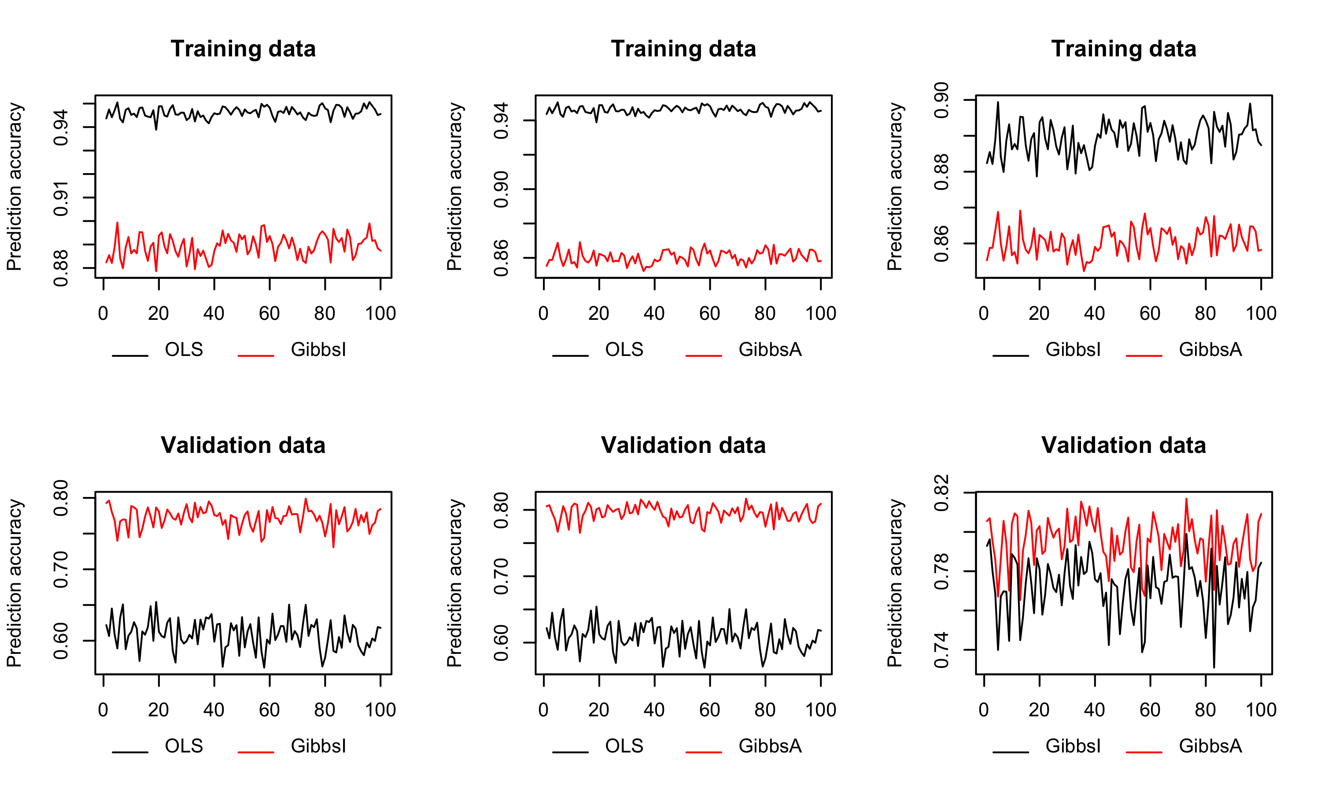**Figure 5**. Prediction accuracy for training and validation sets for the three methods implemented in Box 7.

We also noted in Table 4 that the correlations (here we reported results only for the first replicate) for the parameter estimates among different models reduced compared to Example 1 due to the missing values. For example, the correlation for the estimated **b** among different models reduced to 0.85 between OLS and GibbsI, 0.64 between OLS and GibbsA, and 0.79 between GibbsI and GibbsA.

**Table 4**. Pearson’s product-moment correlation between parameter estimates derived by each of the three methods implemented in Box 7 (results from the first replicate only).

|  |  |  |  |
| --- | --- | --- | --- |
|  | OLS-GibbsI | OLS-GibbsA | GibbsI-GibbsA |
|  | 1.00 | 1.00 | 1.00 |
|  | 0.85 | 0.64 | 0.79 |
|  | 0.96 | 0.74 | 0.77 |
|  | 0.91 | 0.87 | 0.97 |

# Computation time for 599 wheat lines

We ran the FW function in an Intel Core i7 1867 MHz Processor (R was executed in a single thread) with 16 GB of RAM memories. We recorded the memory and time usage for Gibbs methods with 50000 iterations. With the full dataset (599 varieties, 2396 observations) the process used approximately 50 M of RAM memory for GibbsA, 17 M of RAM for GibbsI and 153 M for OLS. The time needed to finish the process was: 11 minutes for GibbsA, 3 minutes for GibbsI and 2 seconds for OLS.

# Concluding Remarks

The FW package allows fitting Finlay-Wilkinson regression with ordinary least square method and Bayesian method. For Bayesian method, covariance matrix among varieties and environments can be included in the model. The interface allows the user to fit the models (e.g. OLS versus Gibbs) and visualize the results easily. The algorithms for Gibbs Sampler are implemented in C and the speed is high. The package also provided flexibility for changing the hyper-parameters and model output.

For incomplete/unbalanced experimental design the Bayesian approach is expected to have better statistical performance and prediction accuracy than the traditional two-step OLS method. Furthermore, the Bayesian models implemented in FW allows incorporating pedigree, marker information as well as modeling spatial processes. A cross-validation study based on real wheat data confirmed those expectations; indeed, the Bayesian method incorporating relationships between lines had a prediction accuracy that was 30% greater than the two-steps OLS method.

# Acknowledgements

We thank the collaborators in national agricultural research institutes who carried out the Elite Spring Wheat Yield Trials (ESWYT) and provided the phenotypic data analyzed in this article. GDLC and LL received financial support from NIH grants R01GM101219 and R01GM099992 and from Arvalis. GDLC received financial support from Arvalis and CIMMYT.

# References

# Casella, G., and E. I. George, 1992. Explaining the Gibbs sampler. The American Statistician 46: 167-174.

# Copas, J. B., 1983. Regression, prediction and shrinkage. Journal of the Royal Statistical Society. Series B (Methodological) 45: 311-354.

# Crossa, J., G. de Los Campos, P. Pérez, D. Gianola, J. Burgueño, J. L. Araus, D. Makumbi, R. P. Singh, S. Dreisigacker, and J. Yan, 2010. Prediction of genetic values of quantitative traits in plant breeding using pedigree and molecular markers. Genetics 186: 713-724.

# Finlay, K., and G. Wilkinson, 1963. The analysis of adaptation in a plant-breeding programme. Crop and Pasture Science 14: 742-754.

# Frank, L. E., and J. H. Friedman, 1993. A statistical view of some chemometrics regression tools. Technometrics 35: 109-135.

# Geman, S., and D. Geman, 1984. Stochastic relaxation, Gibbs distributions, and the bayesian restoration of images. IEEE Transactions on Pattern Analysis and Machine Intelligence 6: 721-741.

# Gregorius, H.-R., and G. Namkoong, 1986. Joint analysis of genotypic and environmental effects. Theoretical and Applied Genetics 72: 413-422.

Jarquín, Diego, José Crossa, Xavier Lacaze, Philippe Du Cheyron, Joëlle Daucourt *et al*., 2014. A reaction norm model for genomic selection using high-dimensional genomic and environmental data. Theoretical and applied genetics 127: 595-607.

# Perkins, J. M., and J. Jinks, 1968. Environmental and genotype-environmental components of variability III. Multiple lines and crosses. Heredity 23: 339-356.

# Plummer, M., N. Best, K. Cowles, and K. Vines, 2006. CODA: convergence diagnosis and output analysis for MCMC. R News 6: 7-11.

# Pérez, P., G. de Los Campos, J. Crossa, and D. Gianola, 2010. Genomic-enabled prediction based on molecular markers and pedigree using the bayesian linear regression package in R. The Plant Genome 3: 106-116.

R Development Core Team, 2011. R: a language and environment for statistical computing. R Foundation for Statistical Computing, Vienna and Austria.

# Shariati, M., I. Korsgaard, and D. Sorensen, 2009. Identifiability of parameters and behaviour of mcmc chains: a case study using the reaction norm model. Journal of Animal Breeding and Genetics 126: 92-102.

# Su, G., P. Madsen, M. S. Lund, D. Sorensen, I. R. Korsgaard, and J. Jensen, 2006. Bayesian analysis of the linear reaction norm model with unknown covariates. Journal of Animal Science 84: 1651-1657.

Walsh, J. B., and M. Lynch, 2014. Chapter 44 Selection and G x E: Advanced Topics. *In* Evolution and Selection of Quantitative Traits: II. Advanced Topics in Breeding and Evolution. Available at http://nitro.biosci.arizona.edu/zbook/NewVolume_2/pdf/Chapter44.pdf (verified 05 Dec. 2015).